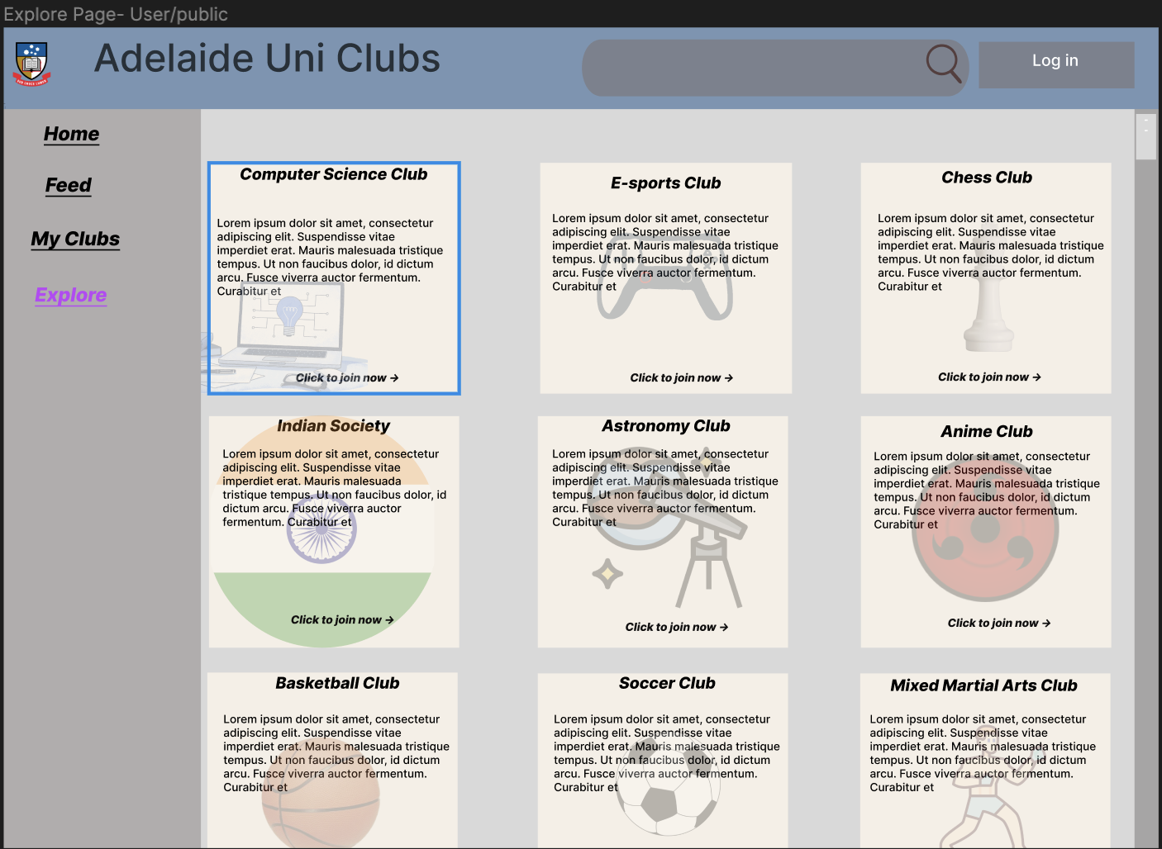

4

3

1.Sidebar

(922px x 247px)

-Provides quick access to main pages within the application. Current page is in a different colour (Explore Page)

2.Club Cards

(288px x 312px)

-Displays short description of the club, with their icon in the background, allowing users to join.

3.Search Bar

(71px x 483px)

-Allows users to quick search for pages/clubs

4.Log In

(58px x 194px)

-Quick Access to the log in page to enable users to view a more personalised version of this page

2

1

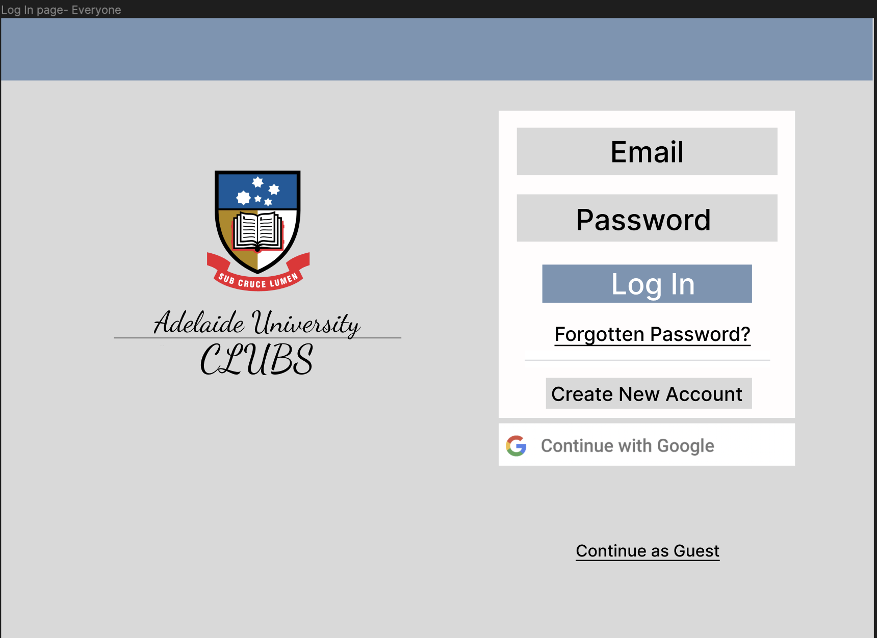1.Email Text Input

1.Email Text Input

(78px x 430px)

-get the user’s email to log in to the account

2.Password Text Input

(78px x 430px)

-get the user’s password to log in to the account

3.Log in Button

(63px x 346px)

-once email and password is entered, if correct to database, redirects to the home page. If not, throws an error

4. Create New account

(51px x 340px)

-redirects user to the register page

5.Continue with Google

(70px x 489px)

-allows users to use their google account (Gmail) to log in to the app

(78px x 430px)

-get the user’s email to log in to the account

5

4

3

2

1

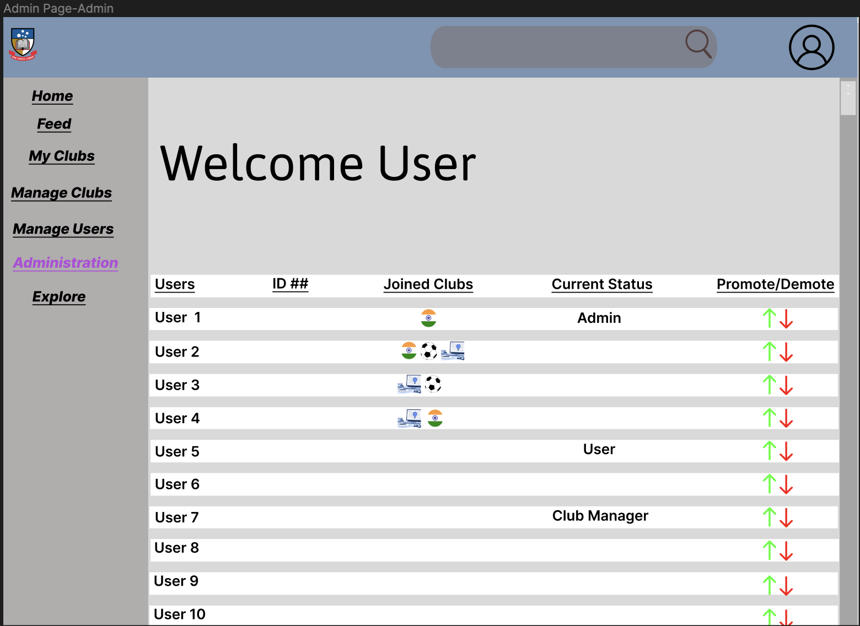

1.Promote/Demote Button

(0px x 31px)

-Allows admins to promote users to admins or club managers, as well demote them to regular members

1

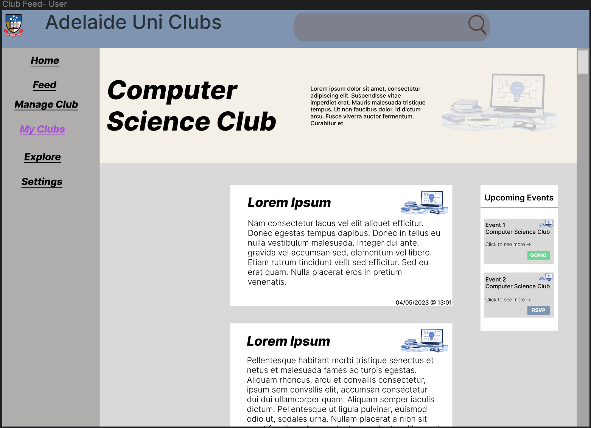

1.Club Posts

(297px x 545px)

-Displays each post that is made on the specific club page, with details such as time and date the post is published.

2.Event Cards

(111px x 171px)

-Displays any upcoming events related to the particular club and their vital details. Can click to expand for more details. Going/RSVP button shows whether the user has already or yet to RSVP (22px x 56px)

2

1

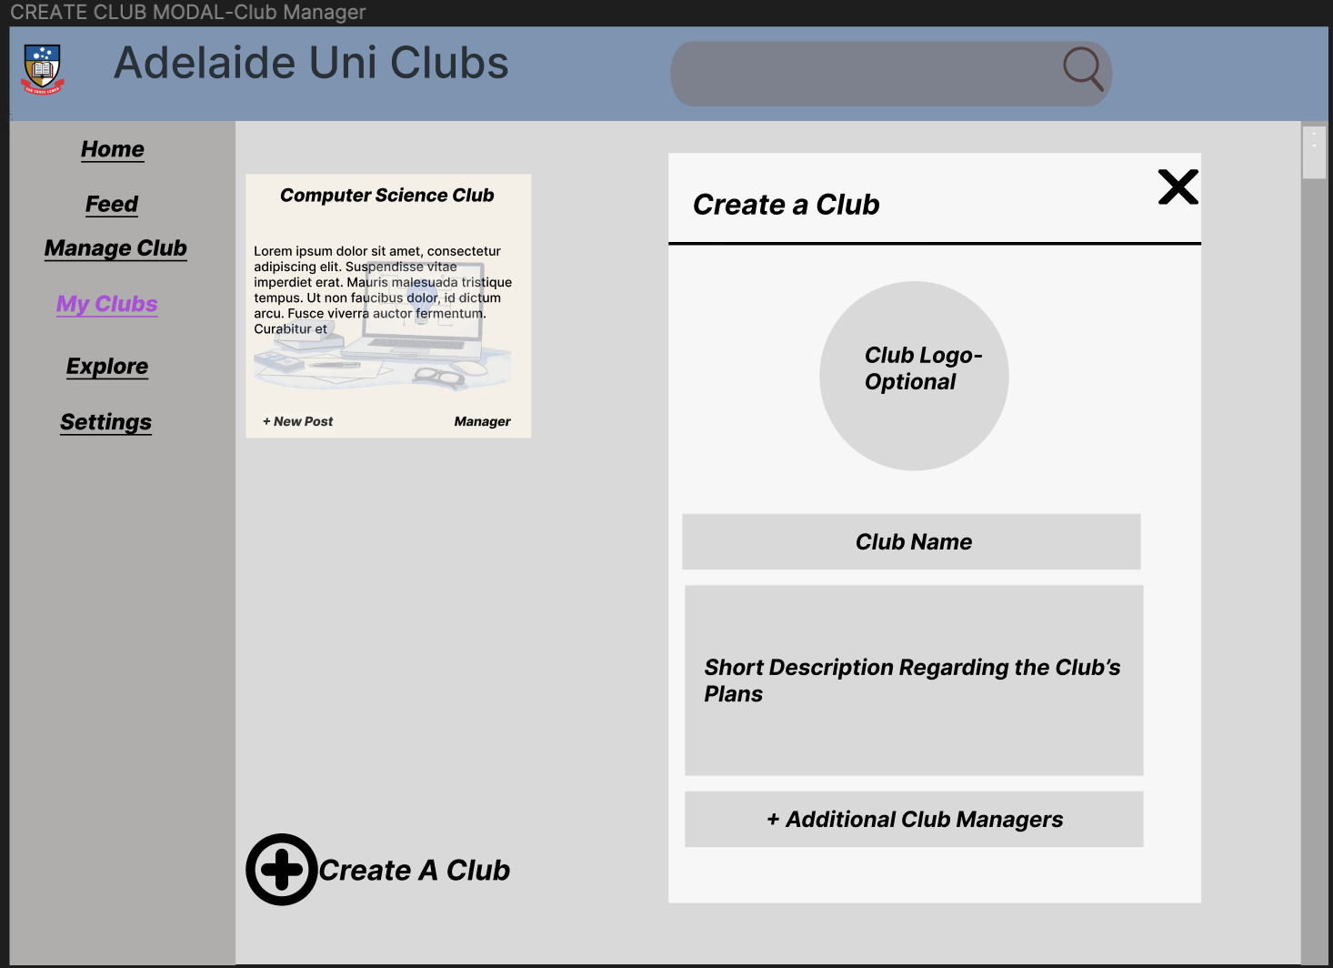

2

1.Create-a-club button

(79px x 79px for + and 58px x 300px for text)

-when clicked, the “create a club modal” is displayed

2.Create-a-Club Modal

(819px x 582px)

-displays and requests the information required to make a club to be inputted.

3. Club Logo

(207px x 207px)

-Allows users to upload an image that would be used as the club logo, appearing anywhere anything regarding the club is seen.

4. Club Name

(61px x 501px)

-Requests the name of the club to be made.

5. Short Description

(208px x 507px)

-requires a short description that would explain the club’s purpose, plans and motivations.

6. Additional Club Managers

(61px x 501)

-Allows the maker of the club to entitle other members as additional club managers.

6

5

4

3

1

1.Create-a-New-Post Modal

(819px x 582px)

-Displays and requests the information required when making a post

2.Title text input

(51px x 534px)

-requires the title of the post to be inputted.

3. Content text input

(247px x 534px)

-requires the content of the post itself

4. Private Slider

(53px x 126px)

-if the post is set to private, only members of the club can view it. If not set to private, it can be viewed by anyone.

5. Post Button

(53px x 168px)

-when pressed, the post becomes published and viewable

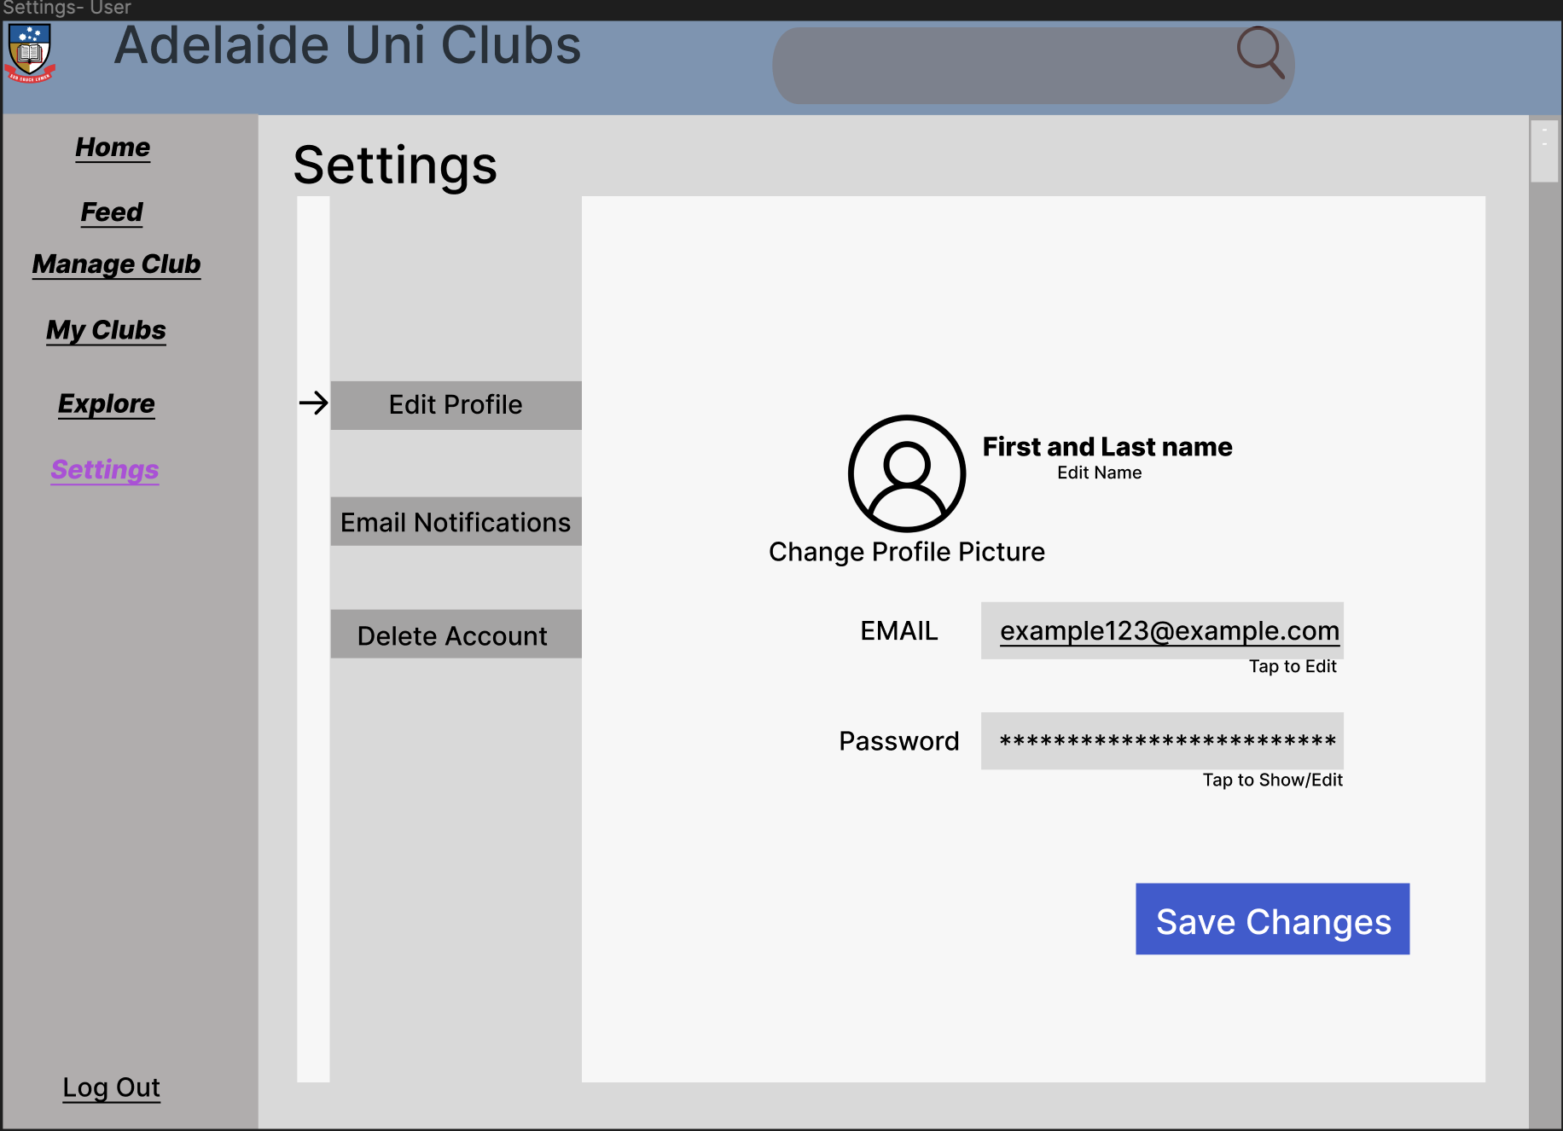

4

2

**1**

5

3

1.Setting categorisation Buttons

(45px x 232px)

-Categorizes all the setting options into three quick access buttons to be easily navigated

2.First and Last name Field

(29px x 232px)

-Displays the first and last name of the user and allows edits to be made if needed

3.Profile Picture Field

(131px x 131px)

-displays user’s profile picture. Profile picture can also be changed from here

4.Email Text Field

(53px x 335px)

-shows current email that was used to create the account. Also allows to edit/change the email if wanted

5.Password Text Field

(53px x 335px)

-shows current password that is used to log in to the account. Also allows to edit/change the password if wanted

6. Save Changes Button

(66px x 253px)

-when pressed, any changes that may have been made would be saved and updated in the database.

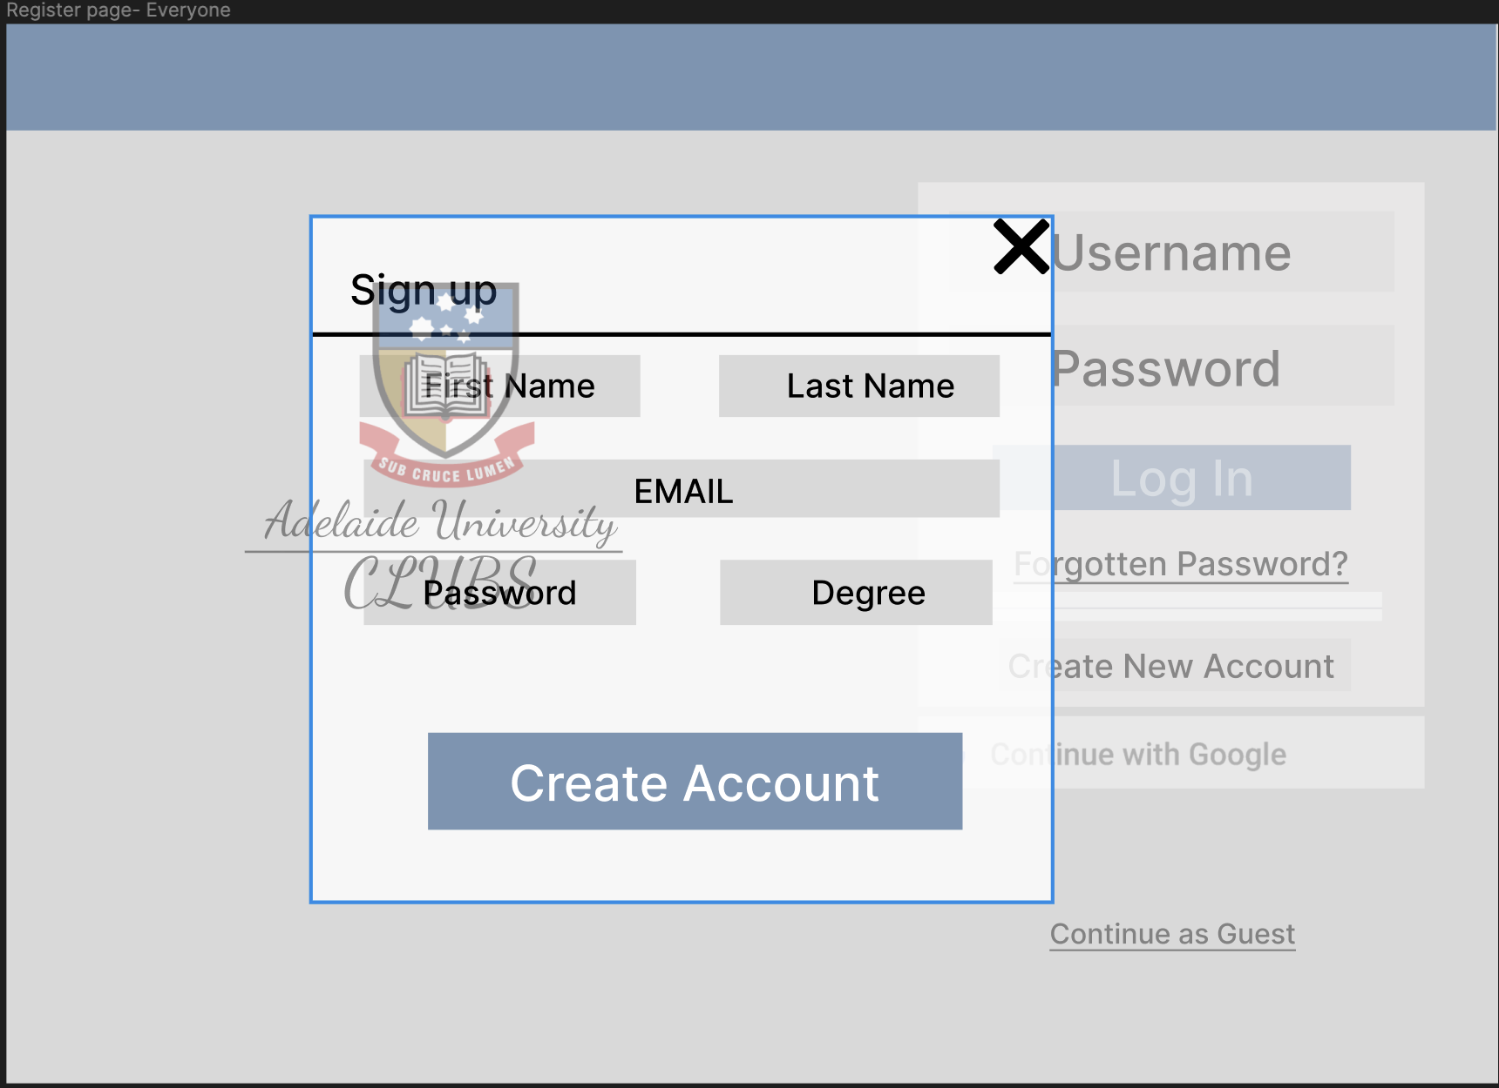

1

3

4

5

6

1.First name Input

(60px x 271px)

-gets the users first name to make an account

2.Last name Input

(60px x 271px)

-gets the users last name to make an account

3.Email text Input

(56px x 614px)

-gets the user’s email to make an account and for future sign-ins

4. Password text input

(63px x 263px)

-gets the user’s password for future sign-ins

5. Degree text input

(63px x 263px)

-gets the user’s degree that they are studying for analytics/database purposes

6. Create Account Button

(94px x 516px)

-uses and stores all the previously entered information to create an account